**The Current State of LSP Suitability Maps in Multi-Criteria Decision Support Systems**

Cole MacLean

March 17, 2016

# Introduction

The growing application of Multi-Criteria Decision Support Systems (MCDSS) in problem-sets dealing with geospatial information has led to the development of advanced methods in modeling specialized maps for the degree of suitability in select geographic locations based on specified purposes. One such method is known as Land Suitability Potential (LSP) maps, developed by Jozo J. Dujmovic et al (Dujmovic, 2009). In their paper, the authors describe a methodology for producing suitability maps that utilize multiple target attributes to support decision makers in selecting optimal geographic locations for projects such as infrastructure, agriculture, environmental protection and urban development plans. In this paper, we review the methodology described by Dujomovic, its application to specific real-world problems and compare the proposed methodology to other methods for building Decision Support Systems for geospatial problem-sets.

# LSP Methodology

## 2.1 Methodology Overview

In the LSP methodology described by Dujmovic et al, a set of geographic locations are represented by 2-dimensional (X,Y) scaler indicators that contain an array of n-attributes (a1,a2,…..an) that characterize important features of a location for use in a specific application. These attributes can represent physical characteristics such as a terrain’s topology, anthropologic characteristics such as existing infrastructure, and meteorological characteristics such as prevailing climate. These defined attributes are utilized to quantify the soft computing logical function, E, with a normalized form of E=G(a1,a2,…..an) ϵ [0,1] where E represents the suitability of a geographical location, E=0 being the minimum suitability and E=1 being the maximum suitability.

Once a unique set of attributes is identified, elementary criteria functions are developed to map the degree to which a location’s attribute, ai, satisfies a specific requirement of the attribute class or, the preference for a given location given the suitability of the evaluated attribute. An elementary criteria function is defined as ei = gi(ai) where ei is the preference of a given (X,Y) location using the criteria function, gi, parameterized by the locations specific attribute, ai.

Once elementary criteria functions are defined and location preferences are computed for each attribute in the attribute set (a1,a2,…..an), a preference aggregation function is developed to generate the overall preference value for a specified (X,Y) location: E(X,Y) = λ(g1(a1),…,g1(an)) where λ is the aggregation function over the computed preferences of each attribute. Computing the overall preference value for each (X,Y) pair forms the suitability map defined by E(X,Y), Xmin ≤ X ≤ Xmax, Ymin ≤ Y ≤ Ymax.

Figure 1 outlines the mathematical depiction of the above methodology, and Figure 2 outlines the algorithmic procedure.

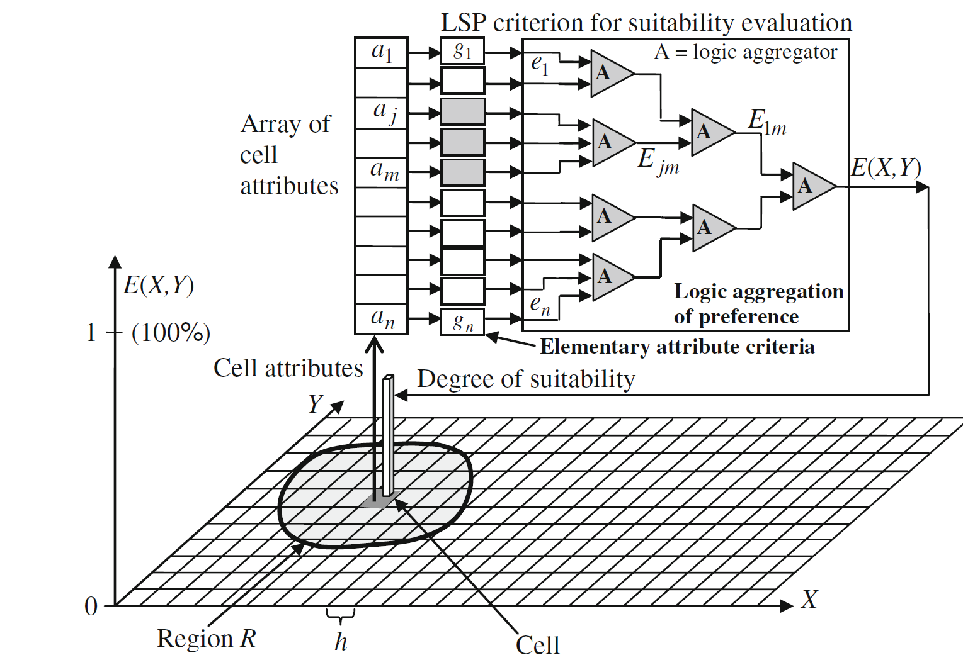

Figure : The Concept of LSP-Maps (Dujmovic, 2009)

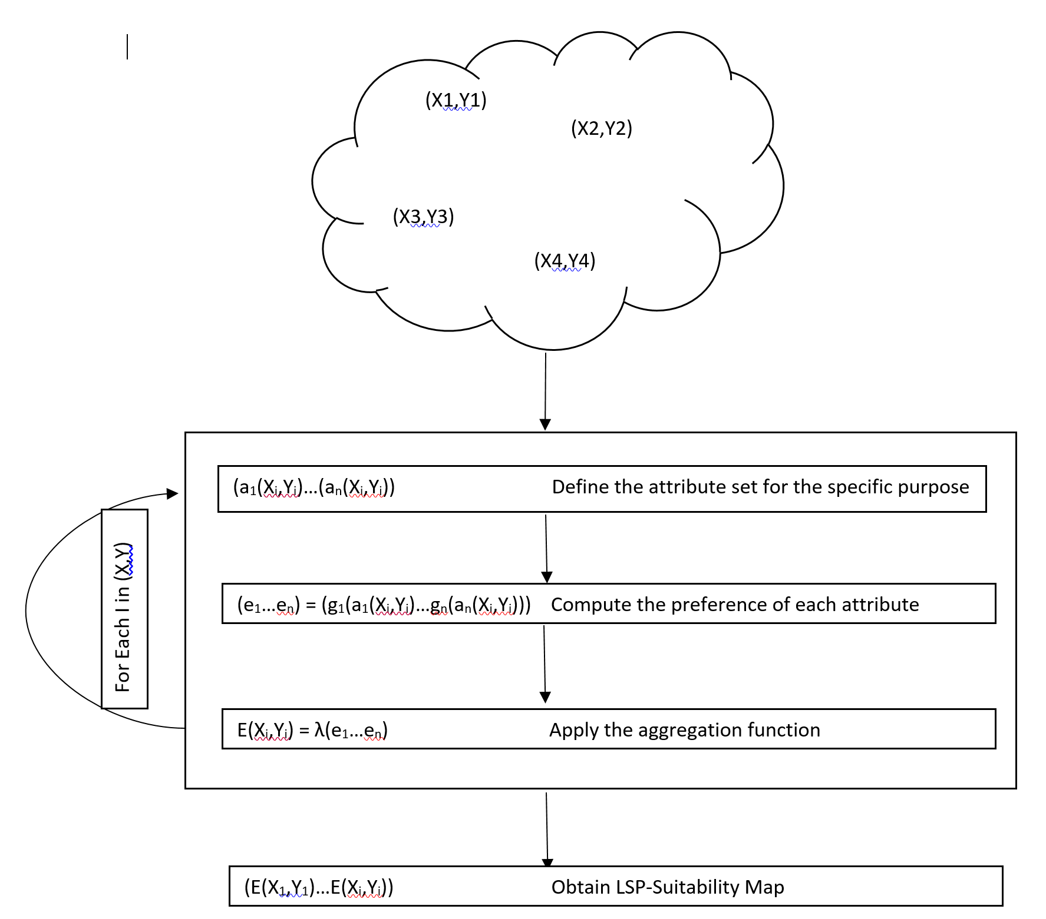

Figure : LSP-Map Algorithm Design

## 2.2 Defining Attributes

The first step in the LSP-Map methodology is defining the attributes associated with a specific target application for a set of geographical locations. This step consists of decomposing macro characteristics of a geographical location into less complex subsets of characteristics that can be better assigned a measure of “usefulness” for a given application. The hierarchical decomposition is exhausted by reaching a subset of components that are sufficiently simplistic as to no longer yield a simpler sub-composition. This stop-condition subset represents the set of preference attributes utilized in the LSP-methodology.

### 2.2.1 Attribute Decomposition Example

Figure 3 illustrates an example decomposition to define preference attributes for urban expansion.

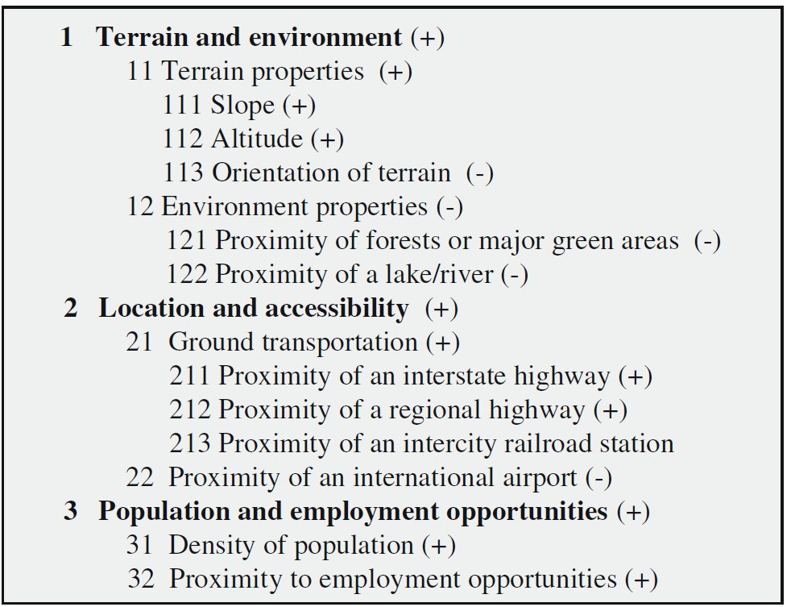

Figure : Example Attribute Decomposition Tree (Dujmovic, 2009)

The geographic locations are assign 3 macro characteristics: Terrain and Environment, Location and Accessibility and Population and Employment Opportunities. These macro characteristics are decomposed into simpler attributes of components that makeup the parent macro attribute. The subcomponents are further decomposed if a simpler representation of the resulting component exists. The lowest level of each macro characteristic decomposition tree are then grouped together and define the preference attribute set for this particular geographic application problem. Weights can also be assigned to each subcomponent to define its contribution to the makeup of macro parent component.

## 2.3 Elementary Preference Functions

The second step of the LSP methodology is to define the elementary preference functions for each attribute in the preference attribute set. There are many methods of defining elementary preference functions, but 3 piecewise linear forms are generally used:

1. Monotonically Increasing – Used when the relationship between the attribute and its preference are positively and linearly correlated (ie. The distance from a landfill and the preference to be far away from a landfill)
2. Monotonically Decreasing – Used when the relationship between the attribute and its preference are negatively and linearly correlated (ie. The distance from an airport and the preference to be near an airport)
3. Trapezoid Filtering – Used when the relationship between the attribute and its preference has an interval a peak preference, but declines a both the negative and positive edges of that interval (ie. Population density, where both too sparse and too populace is undesired)

Figure 4 depicts examples of these elementary preference functions.

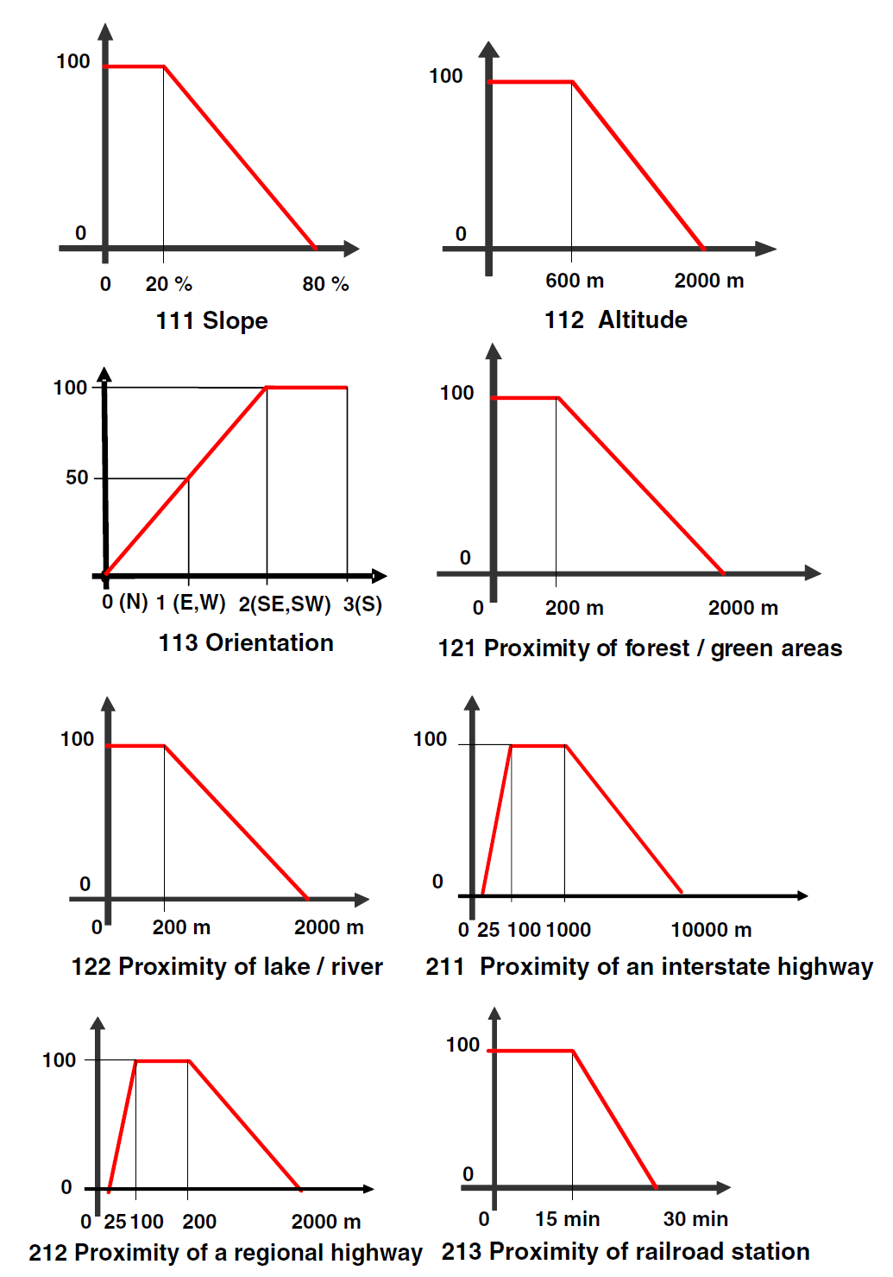

Figure : Example Elementary Preference Functions (Dujmovic, 2009)

## 2.4 Aggregation Functions

The third step in the LSP methodology is to define the aggregation function that generates the overall preference value of a given geographic location, (X,Y). Aggregation functions are an ongoing area of research in Multi-Criteria Decision Support Systems and a substantial amount of methodologies exist for preference aggregation. In their paper, Dujmovic et al. define fundamental classifications of aggregation functions or Continuous Preference Logic (CPL), summarized in Table 1.

Table Classification of Fundamental CPL Aggregators: (Dujmovic, 2007)

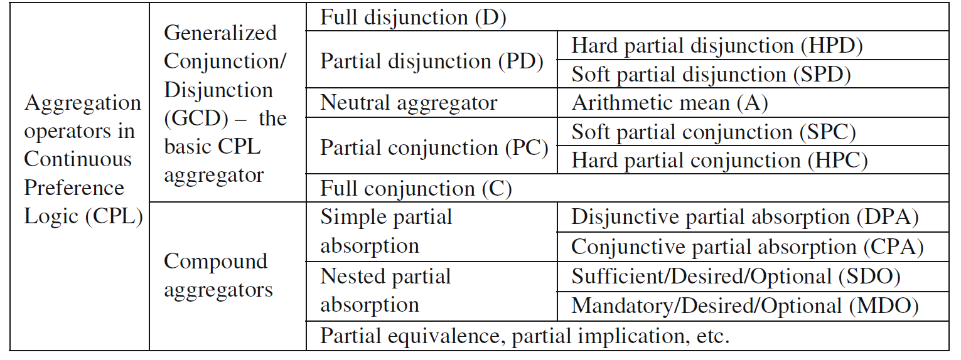

These fundamental methods of aggregation aim to represent the properties of human evaluation reasoning, utilizing the concepts of conjunction and disjunction to model the varying degrees of preference aggregation through fully mandatory criteria, where each attribute must be fully satisfied, to neutral arithmetic means where each attribute has an equal weight, to full orness aggregation, where only one attribute needs to be satisfied to obtain a high preference value. The definition and application of these aggregation functions is outside the scope of this paper, but many papers exist that describe the derivations and applicability of these and other aggregation functions: (Dujmovic, 2009), (Yager, 2016), (Dujmovic, 2007).

## 2.5 Further Considerations

Further consideration must be given to details external to the outlined LSP methodology. The above methodology derives a suitability map developed from the preference of a given set of attributes, but does not outline the role of a cost function, usually financial, to a proposed location. Specific details about the availability and quality of the necessary data to perform the proposed analysis also needs to be considered.

### 2.5.1 Cost Functions

In their paper, Dujmovic et al recommend to separate the concept of the cost of a geographic location in use of a specific application from the overall preference evaluation. (Dujmovic, 2009) In this way, a suitability map can be generated representing the preference of locations given desired attributes, and the overall suitability can be developed by aggregating the preference map with the associated cost function. This provides a conceptually intuitive formulation of the problem. Figure 5 depicts the overall suitability computation given a preference and cost of a geographic location.

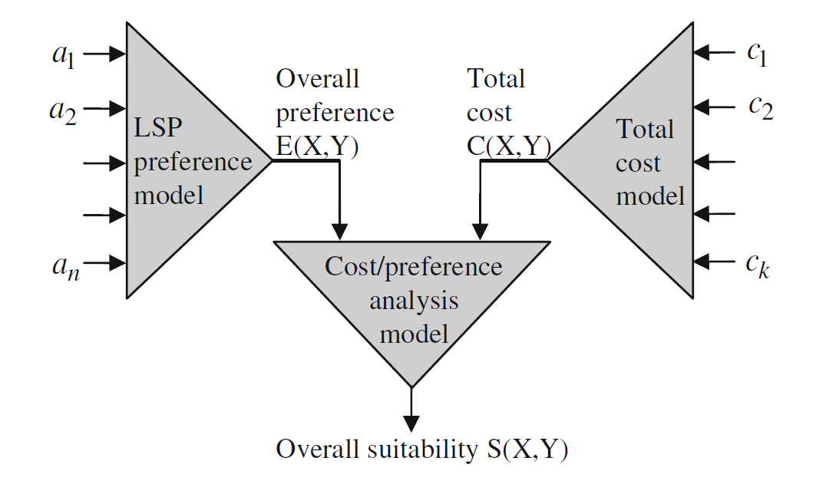

Figure : Cost/Preference Model (Dujmovic, 2009)

### 2.5.2 Data Considerations

The proposed methodology inherently assumes the availability and reliability of the data required to perform the computations. There are many internet resources available for the data scraping and gathering for particular problems, but the management and quality control of missing or inaccurate data is an ongoing area of research. Many methods for data quality assurance exist, such as: (Wang, 1995) and (Svanks, 1988).

# 3.0 Methodology Comparison

The LSP methodology builds upon predecessor methodologies that consist of similar conceptual frameworks, but LSP improves upon the robustness and applicability of these methods by allowing practitioners to dynamically update input assumptions and directly quantify the influence on the resulting suitability map.

## 3.1 Outranking Methods

In their paper, Joerin et al utilize a mathematical formulation of the outranking methodology, ELECTRE-TRI to establish the suitability map for land-use planning. (Joerin, 2001) Although this method provides the desired ranking of a suitability map, it does not provide the interpretability to establish how much better one location is to another. This causes limitations to the application of this method when considering cost functions in the analysis, and does not allow users to dynamically adjust input assumption parameters and observed a quantifiable change in the suitability map. Only a re-ordering may be observed, but no representation for the magnitude of the changes impact exists in the proposed methodology.

## 3.2 Additive Scoring Methods

Another method for developing suitability maps by Wood and Dragicevic, relies on simple additive scoring to quantify location preferences in the suitability map. (Dragicevic, 2007) Although this method allows for direct reasoning about the difference in quality of two locations for a particular application, the aggregation of preferences does not adequately model the complex reasoning of humans in multi-criteria decision making. The LSP methodology improves upon the Additive Scoring method by allowing for more complex aggregation of preferences, more closing representing the complexities of human decision making.

# 4.0 Application of Suitability Maps

## 4.1 SEAS

The main organization utilizing LSP is System Evaluation and Selection (SEAS) consulting, co-founded by the developer of the LSP methodology, Dr. Jozo J. Dujmovic. Their organization utilizes the LSP methodology to develop Decision Support Systems for client projects such as Evaluation of Search Engines, Optimum Location of Urban Projects and Optimization Computer Configurations. (SEAS, 2016)

## 4.2 Further Applications

The applications of suitability maps are wide and diverse. Teams of researchers are utilizing suitability map methodologies to build Decision Support Systems for their specific needs. In China, a group of researchers are utilizing the technique to determine land-use suitability for urban development in Beijing. (Liu, 2014) In their paper, they outline a methodology of Suitability Maps utilizing Ideal Point Method(IPM) and Ordered Weighted Averaging(OWA) techniques to develop the suitability map. In Ohio, a research group has utilized suitability maps to determine the ideal locations for wind farms. (Gorsevski, 2012) And in Texas, a group has applied suitability mapping techniques to assist in locating a hazardous facility. (Kim, 2014)

# 5.0 LSP Relationship with MCDA and AI

LSP is an applied methodology that utilizes many Multi-Criteria Decision Analysis techniques. Each of the 3 main steps in the methodology lean heavily on the foundational theory of MCDA and AI. In the first step of attribute definition, analyzing the available data and its quality is required to determine the practicality of defining certain attributes. Handling missing and inaccurate data is fundamental in building intelligent, data-driven systems. The evaluation of relationships in a locations feature and its impact on preference also needs to be conducted. This stage in MCDA is often called Exploratory Data Analysis (EDA), and is a fundamental technique in developing Intelligent Decision Support Systems and Artificial Intelligent agents. The second step requires the application of representing the degree of preference for certain attributes, a fundamental problem in Knowledge Representation and Reasoning in order to represent fuzzy values and distributions. The third step requires the application of aggregation functions, a fundamental area of study in Multi-Criteria Decision Support Systems. LSP takes all these concepts developed from MCDA and AI generally to be applied to a specific class of problems that include geographical locations and the inherent characteristics that these problem-sets contain.

# 6.0 Conclusions

LSP is a powerful technique for developing suitability maps and understanding the ordered preference of a set of locations given a specific application. This technique builds on similar methods and improves them by allowing for dynamic representation of the resulting preference suitability map and facilitating the complex aggregation functions required to adequately model human reasoning in decision making. This robust method of suitability map development allows for broad applicability to geographical based problem-sets, such as Urban/Rural land uses such as aquaculture and condo development, Energy and infrastructure development such as windfarm projects and environmental impact studies in the development of hazardous facilities. With the growing need for conscientious and intelligent decision making in land-use policy due to increasing global populations and the industrialization of third-word nations, the techniques described in this paper will become increasingly more important for use in real-world applications.

# References

Dragicevic, W. a. (2007). GIS-based multi-criteria evaluation and fuzzy sets to identify priority sites for marine protection. *Biodiverse Conserve*, 2539-2558.

Dujmovic, J. J. (2007). Preference Logic for System Evaluation. *IEEE*, 1082-1099.

Dujmovic, J. J. (2009). LSP Suitability Maps. *Springer*, 14.

Gorsevski, P. V. (2012). A group-based spatial decision support system for wind farm site selection in northwest Ohio. *Energy Policy*.

Joerin, F. (2001, March). Using GIS and outranking multicriteria analysis for land-use suitability assessment. *INTERNATIONAL JOURNAL OF GEOGRAPHICAL INFORMATION SCIENCE*, pp. 153-174.

Kim, H. Y. (2014). Land use suitability and Social and Ecological factrsfor locating a new hazardous facility. *Journal of Civil Engineering*, 359-366.

Liu, R. (2014). Land-use Suitability analysis for urban development in Beijing. *Journal of Environmental Management*.

SEAS. (2016, March 19). *Resources and Publication*. Retrieved from SEAS: http://www.seas.com/demo.html

Svanks, M. (1988, December). Integrity analysis: methods for automating data quality assurance. *Information and Software Technology*, pp. 595-605.

Wang, R. Y. (1995, August 06). A framework for analysis of data quality research. *IEEE Transactions on Knowledge and Data Engineering*, pp. 623-640.

Yager, R. R. (2016). Modeling multi-criteria objective functions using fuzzy measures. *INFORMATION FUSION*, 105-111.